**Module 4 Assignment**

1. PPC bidding is influenced by several key factors that can impact the cost and success of your campaigns. Here are the main factors that can affect PPC bidding:

* Keyword Competition
* Quality Score
* AD Rank
* Targeting and Relevance
* Ad Scheduling
* Budget and Bidding Strategy
* Ad Copy and Relevance
* Landing Page Experience
* Seasonality and Trends
* Network and Platform

Remember that PPC bidding is a dynamic process, and the factors mentioned above can interact with each other. Regular monitoring, testing, and optimization of your campaigns are essential to achieve optimal bidding results.

1. A search engine typically calculates the actual cost-per-click (CPC) through a bidding system in its advertising platform. Here's a general overview of how it works:

* **Advertiser Bidding:** Advertisers interested in displaying their ads in search engine results participate in an auction-based bidding process. They specify the maximum amount they are willing to pay for each click on their ad, which is known as the maximum CPC bid.
* **Ad Rank Calculation:** When a user performs a search query, the search engine runs an auction to determine which ads to display and in what order. Advertisers' bids and other factors, such as ad quality and relevance, are taken into account. The search engine calculates an ad rank for each ad based on a combination of factors.

**Ad Rank = Max CPC * Quality Score**

* **Actual CPC Determination:** The actual CPC is determined by the ad rank of the advertiser below, divided by the Quality Score of the advertiser and multiplied by a small increment. The Quality Score is a measure of the relevance and quality of the ad and the landing page.
* **Ad Position:** The ads with the highest ad ranks usually secure the top positions in search results. The search engine determines the specific ad positions based on the ad ranks and the layout of the search results page
* **Billing:** When a user clicks on an ad, the advertiser is charged the amount of the actual CPC. The actual CPC can vary depending on the competitiveness of the auction and the Quality Score of the advertiser.

It's important to note that search engines employ complex algorithms and bidding systems to calculate the actual CPC, and the specific details can vary between platforms. Advertisers often have tools and options to manage their bids, budgets, and targeting preferences to optimize their advertising campaigns.

1. Quality Score is a metric used in online advertising, particularly in pay-per-click (PPC) advertising platforms like Google Ads. It is a rating system used by these platforms to determine the relevance and quality of ads and keywords. The Quality Score influences the placement of ads, ad rankings, and the cost-per-click (CPC) for advertisers.

* **Ad Placement:** Quality Score influences the position of your ads in search engine results pages (SERPs) or on other advertising platforms. Ads with higher Quality Scores are more likely to appear in higher positions, increasing their visibility to users. Higher ad positions can lead to greater exposure and more opportunities for users to interact with your ads.
* **Cost-Per-Click (CPC):** Quality Score affects the amount you pay for each click on your ads. Higher Quality Scores can lead to lower CPCs, as the advertising platform rewards ads that are deemed more relevant and valuable to users. This can help maximize your advertising budget and reduce costs, allowing you to achieve a higher return on investment (ROI).
* **Ad Rank:** Ad Rank determines the order in which ads appear on a SERP. It is calculated based on the combination of your Quality Score and your bid. A higher Quality Score allows you to achieve a higher ad rank with a lower bid compared to competitors, giving you a competitive advantage. This means you can potentially outrank competitors while spending less on your advertising campaigns.
* **Ad Performance:** Quality Score is closely tied to click-through rate (CTR), as it measures historical ad performance. Ads with higher Quality Scores generally have better CTRs, indicating that they are more appealing and relevant to users. Improved ad performance can lead to higher conversion rates, more qualified traffic to your website, and overall campaign success.
* **Optimization Opportunities:** Quality Score provides insights into areas for improvement in your ad campaigns. By monitoring your Quality Scores, you can identify keywords or ads that are underperforming and take corrective actions to enhance relevance, ad copy, and landing page experience. This allows you to optimize your campaigns, improve performance, and achieve better results over time.
* **User Experience:** Quality Score encourages advertisers to create high-quality, relevant ads that provide value to users. By striving to improve your Quality Scores, you are indirectly enhancing the user experience, which can lead to better engagement, increased customer satisfaction, and potentially higher conversion rates.

Overall, Quality Score is important for ads because it impacts ad placement, CPC, ad rank, ad performance, and provides optimization opportunities. By aiming for higher Quality Scores, you can increase the visibility and effectiveness of your ads, optimize your ad spend, and ultimately drive better results from your advertising efforts.



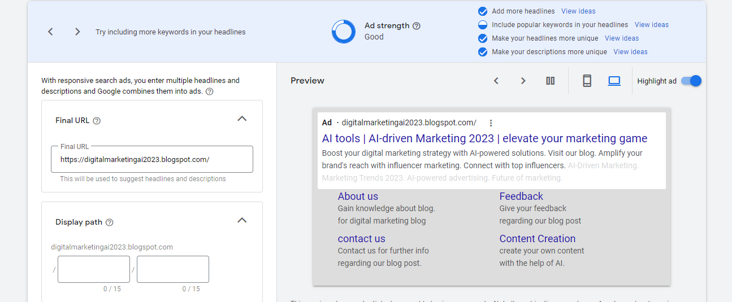

5.

5. 